Library management system

**Display all the tables and Write the queries for the following :**

1. **Retrieve the book title, category, and rental price of all available books.**

SELECT Book_title, Category, Rental_Price

FROM Books

WHERE Status = 'yes';

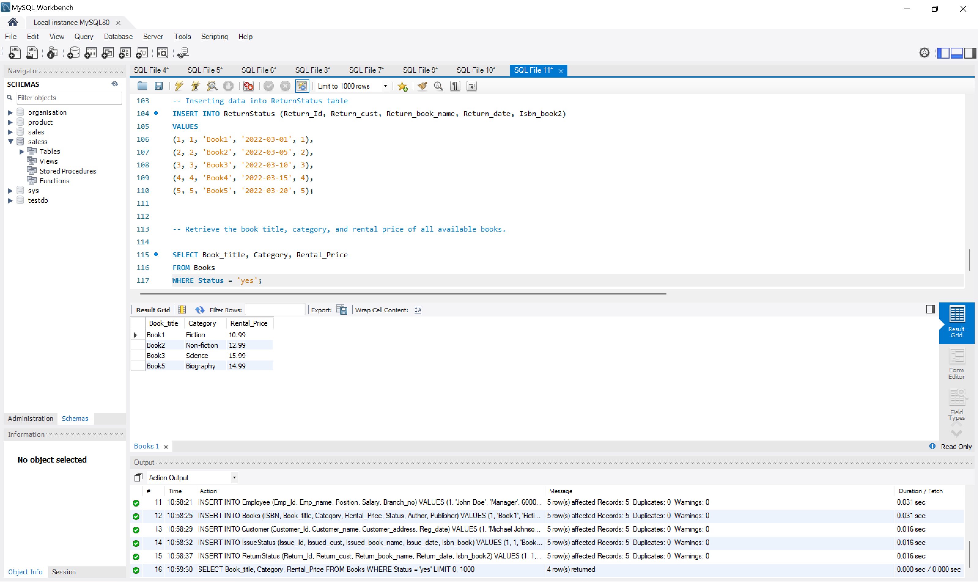

1. **List the employee names and their respective salaries in descending order of salary.**

**SELECT Emp_name, Salary**

**FROM Employee**

**ORDER BY Salary DESC;**

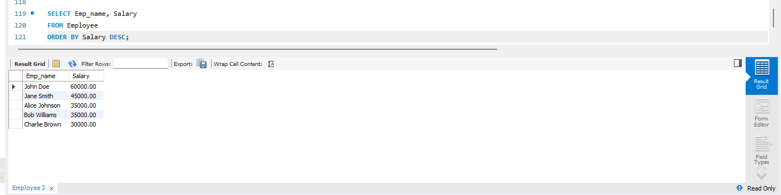  
**3. Retrieve the book titles and the corresponding customers who have issued those books.**

SELECT b.Book_title, c.Customer_name

FROM Books b

INNER JOIN IssueStatus i ON b.ISBN = i.Isbn_book

INNER JOIN Customer c ON i.Issued_cust = c.Customer_Id;

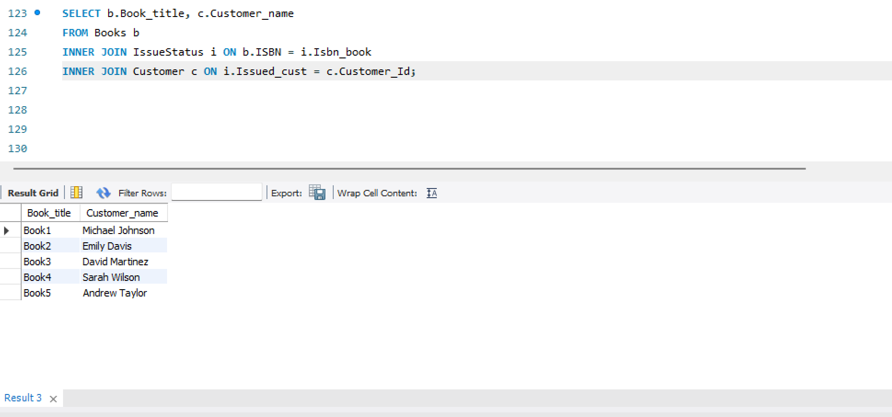

**4. Display the total count of books in each category.**

**SELECT Category, COUNT(*) AS Total_Count**

**FROM Books**

**GROUP BY Category;**

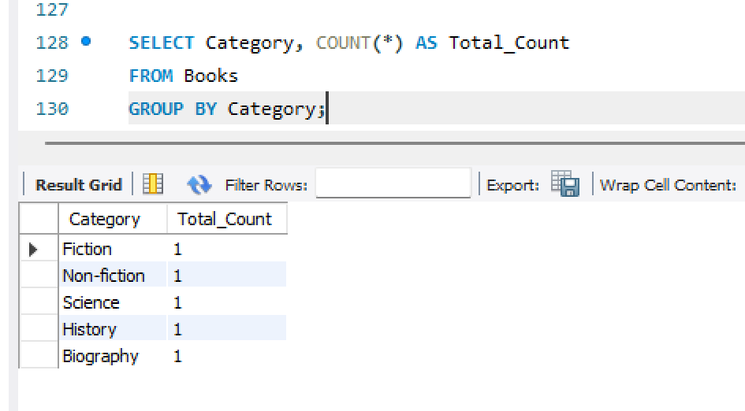

**5. Retrieve the employee names and their positions for the employees whose salaries are above Rs.50,000.**

**SELECT Emp_name, Position**

**FROM Employee**

**WHERE Salary > 50000;**

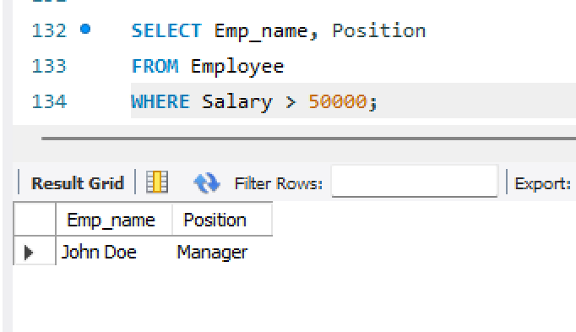

**6. List the customer names who registered before 2022-01-01 and have not issued any books yet.**

**SELECT Customer_name**

**FROM Customer**

**WHERE Reg_date < '2022-01-01'**

**AND Customer_Id NOT IN (SELECT Issued_cust FROM IssueStatus);**

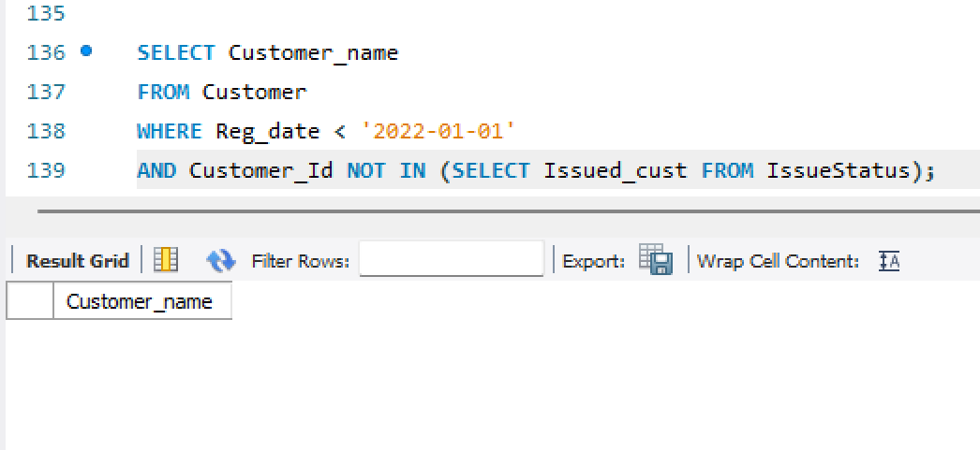  
**7. Display the branch numbers and the total count of employees in each branch.**

SELECT Branch_no, COUNT(*) AS Total_Employees

FROM Employee

GROUP BY Branch_no;

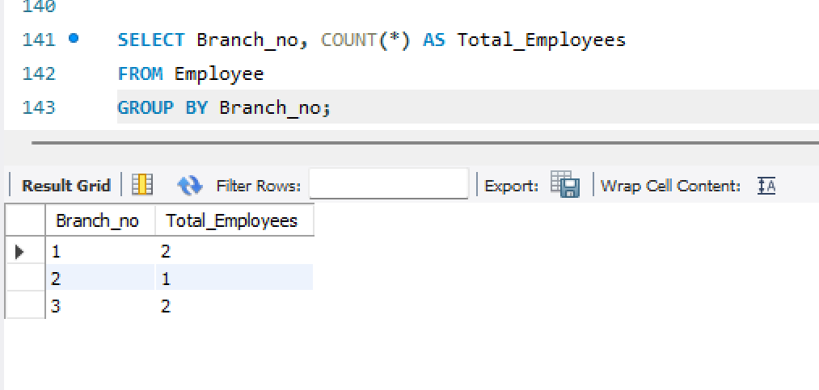  
**8. Display the names of customers who have issued books in the month of June 2023.**

**SELECT DISTINCT c.Customer_name**

**FROM Customer c**

**JOIN IssueStatus i ON c.Customer_Id = i.Issued_cust**

**WHERE YEAR(i.Issue_date) = 2023 AND MONTH(i.Issue_date) = 6;**

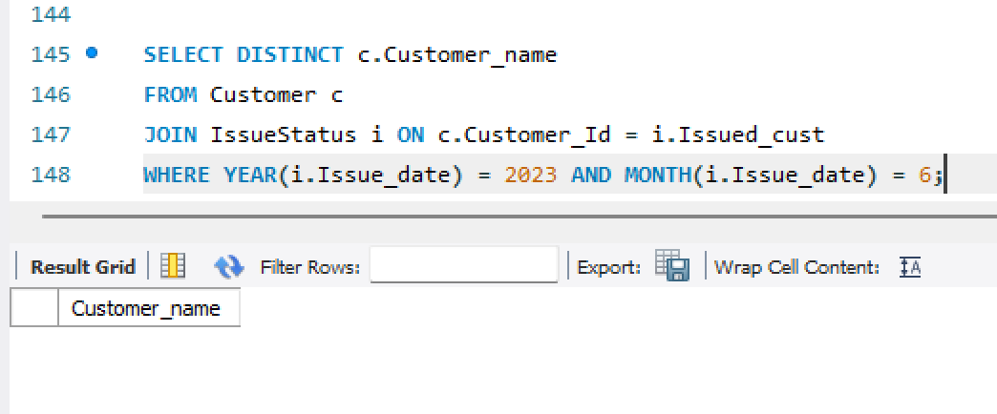

**9. Retrieve book_title from book table containing history.**

SELECT Book_title

FROM Books

WHERE Category = 'History';

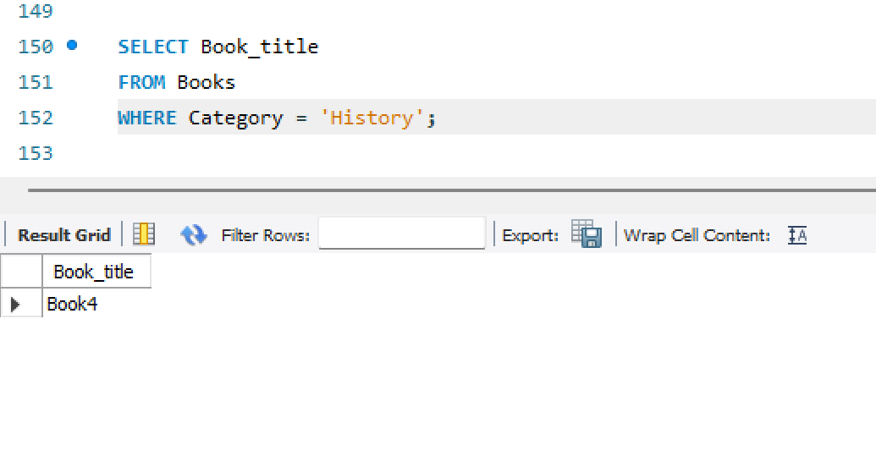

**10.Retrieve the branch numbers along with the count of employees for branches having more than 5 employees**

SELECT Branch_no, COUNT(*) AS Total_Employees

FROM Employee

GROUP BY Branch_no

HAVING COUNT(*) > 5;

